UNIVERSITY OF ENGINEERING & TECHNOLOGYMARDAN
DEPARTMENT OF COMPUTER SOFTWARE ENGINEERING
FINAL YEAR PROJECT PROPOSAL



Natural Language Policy Automation with Intelligent IoT Device Selection
(September-2025)

FYDP Group No.:
Group Members  Muhammad Hammad (Reg # 22MDSWE209)  muhammadhammad010100@gmail.com  Tayyab Ahmad (Reg # 22MDSWE217)  tayyabahmad.ai@gmail.com | Proposed Supervisor:  Name: Dr. Sohail Khan  Signature:
Contact Number: 03429444222, 03101554881

Contents
Introduction 3
Problem Statement 4
Objectives of Project 5
Natural Language Policy Interpretation 5
Automatic IoT Device Selection 5
Vision-Based Condition Verification 5
Policy Scheduling and Execution 5
User-Friendly and Scalable Framework 5
Literature Review 6
Methodology for Implementation of Project 7
Theoretical Foundation 7
System Design and Assembly 8
Experimental Setup 8
Method of Analysis 9
Expected Outcomes 9
Block Diagram Flow Chart 10
Budget Details 11
Project Implementation Schedule 11
Utilization of Project Results 12
Industrial Applications 12
General Public Applications 13
Effective Utilization 13
References 13
FYP to CEP Mapping 14
FYP to SDGs Mapping 15
Undertaking 16
Proposed Supervisor’s Comments 16
Comments of FYP Coordinator 16
Approval by the Chairman of Department 17

Introduction

Internet of Things (IoT) has transformed modern industrial and workplace environments by enabling a wide range of devices—such as sensors, cameras, alarms, and actuators—to interconnect and exchange data. These interconnected devices offer significant potential for improving safety, efficiency, and automation. However, defining and managing policies that govern IoT operations remain a major challenge. Current systems often require users to configure complex rule engines or rely on pre-defined integrations, which makes them less accessible to managers or non-technical users.

Recent advancements in Artificial Intelligence, particularly Large Language Models (LLMs), provide a promising solution to this challenge. LLMs have demonstrated strong capabilities in understanding and interpreting natural language, making it possible to translate user-defined policies into machine-executable instructions. This enables managers to express policies in simple, human-like language rather than relying on programming or technical configurations.

Another challenge in IoT automation is identifying the appropriate devices needed to execute a given policy. For instance, a policy such as “If someone enters Room 2 between 10 pm and 5 am, then ring the alarm in that room” requires the system to intelligently select the relevant devices (e.g., Room 2 camera and Room 2 alarm) without manual mapping. To further enhance policy enforcement, Vision-Language Models (VLMs) can be utilized to process visual data from cameras, enabling the system to detect and verify conditions such as the presence of a person within a specified timeframe.

This project, titled “Natural Language Policy Automation with Intelligent IoT Device Selection”, aims to bridge these gaps by developing an integrated framework that:
- Accepts policies in natural language.
- Automatically maps policies to the appropriate IoT devices.
- Utilizes LLMs for policy interpretation and orchestration.
- Employs VLMs for vision-based verification of conditions.
- Executes tasks autonomously according to the defined rules.

By combining natural language interfaces, intelligent IoT device selection, and vision-assisted verification, this system seeks to make IoT policy automation more accessible, accurate, and practical for real-world environments. The proposed solution not only simplifies policy definition but also ensures robust enforcement, making it particularly valuable for industrial safety, workplace monitoring, and smart environment management.

Problem Statement

The increasing adoption of Internet of Things (IoT) technologies in industrial and workplace environments has created opportunities for automation, monitoring, and safety. However, managing IoT devices and defining operational policies remain complex tasks. Existing IoT platforms typically require users to configure rule engines manually or rely on predefined templates, which demand technical expertise and reduce accessibility for non-technical managers.

Moreover, current solutions often lack the ability to automatically identify and map relevant IoT devices based on a user-defined policy. For instance, when a manager specifies a condition such as restricting access to a particular area after a certain time, the system should be able to determine which devices (e.g., cameras, locks, or alarms) are required for enforcement. This device selection process is usually manual, time-consuming, and prone to errors.

Another limitation is the absence of vision-assisted verification in most policy-based IoT systems. While some frameworks allow scheduling or event-based automation, they cannot leverage real-time visual data (e.g., detecting whether a person is present in a restricted area) to enforce policies effectively. This reduces the reliability of such systems in scenarios requiring situational awareness and safety monitoring.

Therefore, there is a clear need for an intelligent framework that enables policy definition in natural language, automatic IoT device selection, and vision-based verification for robust and accessible IoT automation.

Objectives of Project

The primary objective of this project is to design and implement a framework that enables policy automation in IoT environments through natural language input, intelligent device selection, and vision-based verification. To achieve this, the following specific objectives are defined:

Natural Language Policy Interpretation
- Develop a system that allows managers to define IoT policies in natural language and translates them into machine-executable rules using Large Language Models (LLMs).

Automatic IoT Device Selection
- mplement a mechanism to intelligently identify and map the relevant IoT devices required for executing each policy without manual intervention.

Vision-Based Condition Verification
- Integrate Vision-Language Models (VLMs) to process visual data from cameras for enforcing policies that depend on detecting human presence, activities, or other visual cues.

Policy Scheduling and Execution
- Enable automated scheduling of policies based on time, events, or conditions, ensuring that tasks are executed reliably and consistently.

User-Friendly and Scalable Framework
- Design the system to be accessible for non-technical users while ensuring scalability to support diverse IoT devices and complex industrial scenarios.

Literature Review

In selecting this project, we carried out an extensive review of existing platforms, academic research, and industrial practices related to IoT automation, natural language interfaces, and vision-based monitoring. Through this review, we identified both the potential of current solutions and the gaps that our proposed system seeks to address.
On the consumer side, platforms such as Google Gemini for Home, Amazon Alexa+, IFTTT, and Home Assistant allow users to create automations and routines using natural language commands or simplified rule builders. These systems reduce the barrier to defining device interactions but are primarily targeted at smart home contexts, focusing on convenience rather than industrial safety or policy enforcement. Furthermore, their reliance on pre-defined device integrations limits flexibility in heterogeneous IoT environments.
In the industrial domain, solutions such as AWS IoT Events and Azure IoT Central provide powerful rule engines for detecting events and triggering automated actions. These frameworks are robust and scalable but require rules to be explicitly programmed using structured query or configuration languages, which makes them less accessible to managers or end-users who lack technical expertise.
Academic research has begun bridging this gap by exploring natural language to IoT policy translation. For instance, AutoIoT (2024) proposed an end-to-end system that generates IoT rules from natural language input and checks for policy conflicts. Similarly, LACE (Language-based Access Control Engine, 2025) demonstrates the use of LLMs for generating and verifying IoT access control policies, while Vega (2025) provides a conversational interface for device control and monitoring. These works highlight the potential of Large Language Models (LLMs) in translating user intent into machine-executable rules. However, most of these approaches focus primarily on rule generation and conflict resolution, without integrating vision-based monitoring or comprehensive device mapping.
Parallel advancements in computer vision and Vision-Language Models (VLMs) have demonstrated robust capabilities in tasks such as occupancy detection, anomaly recognition, and activity monitoring (e.g., NVIDIA Metropolis and Intel OpenVINO toolkits). These systems are widely used for industrial surveillance and safety analytics but are not natively integrated with policy-driven IoT automation frameworks.
In summary, while existing platforms and research provide strong foundations in natural language-based automation, IoT rule engines, and visual analytics, an integrated framework that combines natural language policy definition, automatic IoT device mapping, VLM-based condition verification, and automated task execution remains underexplored. This gap highlights the novelty of the proposed system, which aims to unify these components into a single, accessible, and intelligent IoT policy management framework.

Methodology for Implementation of Project

The proposed project will be implemented through a combination of theoretical studies, software development, and experimental validation. The methodology is designed to ensure that natural language policies can be translated into executable IoT tasks, with intelligent device selection and vision-based verification.

Theoretical Foundation
The system builds upon concepts from:
- Natural Language Processing (NLP) and Large Language Models (LLMs) for interpreting user-defined policies.
- IoT Device Orchestration for mapping available devices to required tasks.
- Computer Vision and Vision-Language Models (VLMs) for real-time detection and verification of visual conditions.
- Automation Scheduling for executing policies based on time, events, or environmental triggers.
These theoretical foundations will guide the design of algorithms and system modules.

System Design and Assembly
The project will be divided into interconnected modules:
- Policy Input Module
  - Users (managers) define policies in natural language.
  - Policies are passed to an LLM for parsing and translation.
- Policy Interpretation and Mapping
  - The LLM identifies the condition (e.g., time, presence, environment), required devices, and actions.
  - A device-mapping engine matches the policy to available IoT devices (e.g., cameras, alarms, locks).
- Vision-Based Verification
  - If a policy requires visual input (e.g., detecting a person in a room), camera feeds are analyzed by a VLM.
  - The VLM returns results in structured format (e.g., person_detected=True).
- Task Scheduler and Executor
  - A scheduler ensures that the policy is checked and executed at the defined time interval.
  - The executor sends commands to IoT devices in a standardized format (e.g., LOCK_DOOR(room=1)).
- Feedback and Monitoring
  - The system logs policy execution and outcomes for monitoring and validation.

Experimental Setup
- Hardware: IoT devices such as cameras, alarms, and smart locks for demonstration. In case of limited hardware, virtual simulations or emulated IoT devices will be used.
- Software: Python-based environment with LLM/VLM integration, IoT simulators, and middleware for device orchestration. The system can run either on a local machine (for controlled testing and development) or on cloud platforms (e.g., AWS IoT Core, Azure IoT Hub, or open-source IoT middleware like Node-RED/Home Assistant).
- Datasets: Publicly available image/video datasets for testing VLM-based detection (e.g., person detection datasets).

Method of Analysis
- Functional Testing: Verify that policies written in natural language are correctly interpreted and executed.
- Device Mapping Accuracy: Measure correctness of automatic IoT device selection against expected mappings.
- Vision Verification Accuracy: Evaluate VLM performance in detecting required conditions (e.g., presence of person, object, or activity).
- System Performance: Measure response time, policy execution reliability, and scalability with multiple devices.

Expected Outcomes
- A working prototype that allows managers to define policies in natural language.
- Automatic IoT device mapping and orchestration based on defined policies.
- Integration of VLM for real-time visual verification of conditions.
- A user-friendly, scalable system that demonstrates practical applications in industrial safety, monitoring, and automation.

Block Diagram Flow Chart
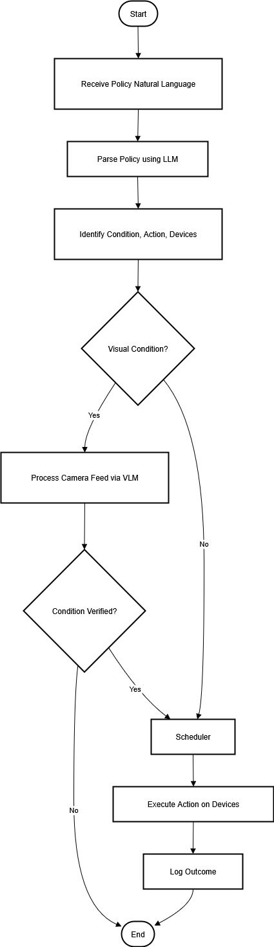
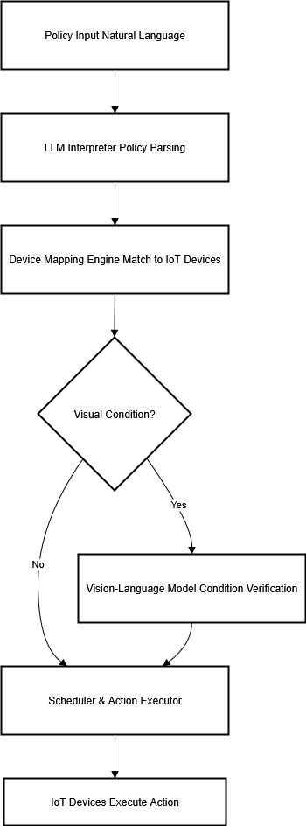

Budget Details

The proposed project is primarily software-driven, with the majority of work carried out on a local machine for development and testing. However, certain costs are expected for IoT hardware components and optional cloud services.
Module / Resource | Description | Estimated Cost (PKR)
Local Machine / Laptop | Existing personal computer for development | 0 (already available)
IoT Cameras (2–3 units) | For visual monitoring (can use USB/web cameras) | 15,000 – 20,000
Smart Alarms / Buzzers | For testing automated alert execution | 5,000 – 7,000
Smart Lock (1 unit) | To simulate access control policies | 8,000 – 10,000
IoT Controller / Microcontroller | (e.g., Raspberry Pi / ESP32) for device integration | 10,000 – 12,000
Cloud Services (Optional) | Hosting, IoT hubs, or LLM API usage (trial/monthly) | 5,000 – 8,000
Miscellaneous | Cables, connectors, power adapters, etc. | 2,000 – 3,000

Project Implementation Schedule

Activity | Month 1–2 | Month 3 | Month 4 | Month 5 | Month 6 | Month 7–8
Literature Collection & Background Study | √
Requirement Analysis & Problem Definition |  | √
System Design & Architecture Finalization |  |  | √
Module Development (LLM + Policy Engine) |  |  |  | √
Integration of VLM & IoT Device Simulation |  |  |  |  | √
Testing, Debugging & Performance Evaluation |  |  |  |  |  | √
Result Analysis & Documentation |  |  |  |  |  | √
Final Report & FYP Submission |  |  |  |  |  | √

Utilization of Project Results
The results of this project will have wide-ranging applications in both industrial and public domains. By enabling managers to define automation policies in natural language and automatically mapping them to available IoT devices, the system removes the need for complex programming or manual configuration.

Industrial Applications
- Industrial Safety & Security: Automated detection of unauthorized access, equipment misuse, or violations of safety protocols can prevent accidents and losses.
- Process Automation: Policies such as equipment shutdown during idle hours or automatic activation of alarms in hazardous areas can improve operational efficiency.
- Energy Management: Automated control of lighting, HVAC, or machinery based on usage policies reduces energy waste and costs.

General Public Applications
- Smart Homes: Users can define policies such as “Lock the main door after 11 PM” or “Turn on garden lights at sunset” without technical expertise.
- Smart Offices & Campuses: Automated meeting room access, surveillance, and environmental control improve convenience and security.
- Public Safety: Surveillance systems in public places (e.g., metro stations, hospitals) can integrate with this framework to automatically trigger alarms or notifications during unusual activity.

Effective Utilization
- Ease of Use: Since policies are defined in natural language, the system can be used by non-technical staff and general users without training.
- Scalability: The system is extendable to different environments—factories, homes, hospitals, campuses, and offices—by integrating additional IoT devices.
- Cost-Effectiveness: By leveraging existing IoT infrastructure (cameras, alarms, locks, sensors), organizations can enhance automation without major new investments.
In conclusion, the project has the potential to bridge the gap between advanced IoT capabilities and practical usability, making automation more accessible, reliable, and intelligent across multiple domains.

References

[1] Yuyang Du, Qun Yang, Liujianfu Wang, Jingqi Lin, Hongwei Cui, Soung Chang Liew, “LLMind 2.0: Distributed IoT Automation with Natural Language M2M Communication and Lightweight LLM Agents,” arXiv preprint, August 2025. arXiv
[2] Leming Shen, Qiang Yang, Yuanqing Zheng, Mo Li, “AutoIOT: LLM-Driven Automated Natural Language Programming for AIoT Applications,” arXiv preprint, March 2025. arXiv
[3] Ye Cheng, Minghui Xu, Yue Zhang, Kun Li, Ruoxi Wang, Lian Yang, “AutoIoT: Automated IoT Platform Using Large Language Models,” arXiv preprint, November 2024. arXiv
[4] H Al-Safi et al., “Vega: LLM-Driven Intelligent Chatbot Platform for Internet of Things Control and Development,” Sensors (MDPI), 2025. MDPIPubMed
[5] Ye Cheng, Minghui Xu, Yue Zhang, Kun Li, Hao Wu, Yechao Zhang, Shaoyong Guo, Wangjie Qiu, Dongxiao Yu, Xiuzhen Cheng, “Say What You Mean: Natural Language Access Control with Large Language Models for Internet of Things (LACE),” arXiv preprint, May 2025. arXiv+1

FYP to CEP Mapping

S# | Attribute | Complex Problem Targeted (Yes/No) | Justification
1 | Preamble* | Yes | The project deals with integrating natural language processing, IoT device orchestration, and vision models — requiring in-depth multidisciplinary engineering knowledge.
2 | Range of conflicting requirements | Yes | It must handle policies that balance safety, security, energy efficiency, and usability, which may conflict in real-world environments.
3 | Depth of Analysis required | Yes | Requires originality in analyzing user-defined policies and translating them into executable IoT tasks, which have no predefined solution.
4 | Depth of Knowledge required | Yes | Relies on research-based knowledge in LLMs, IoT systems, and computer vision, which are at the forefront of computing and engineering.
5 | Familiarity of issues | Yes | The problem of natural language–driven IoT orchestration is novel and not commonly encountered in routine coursework or industry solutions.
6 | Extent of application codes | Yes | No standard codes or practices exist for automatically mapping natural language policies to IoT devices, requiring custom methods.
7 | Extent of stakeholders involved | Yes | Involves managers, operators, and end-users, each with diverse requirements such as security, convenience, or efficiency.
8 | Consequences | Yes | Incorrect execution (e.g., failing to trigger an alarm or lock a door) may have serious safety and security consequences.
9 | Interdependence | Yes | The project is a high-level system integrating multiple sub-problems: policy parsing, device selection, vision verification, and IoT actuation.

FYP to SDGs Mapping

Goal # | Description | Justification
Goal 1 | Good Health & Well-Being | Enhances safety in workplaces, homes, and public areas by automating detection of unsafe or unauthorized activities.
Goal 2 | Affordable and Clean Energy | Policies such as turning off unused devices or scheduling energy usage contribute to efficient energy management.
Goal 3 | Decent Work and Economic Growth | Reduces operational overhead by automating repetitive tasks and improving industrial efficiency.
Goal 4 | Industry, Innovation, and Infrastructure | Promotes innovation by integrating LLMs, VLMs, and IoT for intelligent, policy-driven automation.
Goal 5 | Sustainable Cities and Communities | Can be applied in smart city contexts (e.g., surveillance, automated lighting, smart locks) to improve security and sustainability.
Goal 6 | Responsible Consumption and Production | Optimizes IoT device usage, minimizing waste of resources such as electricity and equipment run-time.
Goal 7 | Peace, Justice, and Strong Institutions | Contributes to secure and transparent monitoring systems in institutions, ensuring compliance with defined rules and policies.

Undertaking

This is to certify that to the best of my knowledge; the content of this project proposal is my own work. This proposal has not been submitted for any degree or other purposes. I certify that the intellectual content of this project is the product of my own work and that all the assistance received in preparing this proposal and sources have been acknowledged.

Muhammad Hammad (22MDSWE209)
Tayyab Ahmad (22MDSWE217)

Proposed Supervisor’s Comments

Dr. Sohail Khan
Computer Software Engineering

Comments of FYP Coordinator

Signature of FYP Coordinator: __________________ Dated:

Approval by the Chairman of Department

Signature: __________________ Dated: _____________________

